Министерство образования и молодежной политики Свердловской области



ГАПОУ СО «Екатеринбургский колледж транспортного строительства»

Отчёт по программе «**Практическая работа 19_1**»

Выполнил: Сэпселев Тимофей Дмитриевич

Группа: ПР-22

Преподаватель: Мирошниченко Г.В

2023

**Задание:** 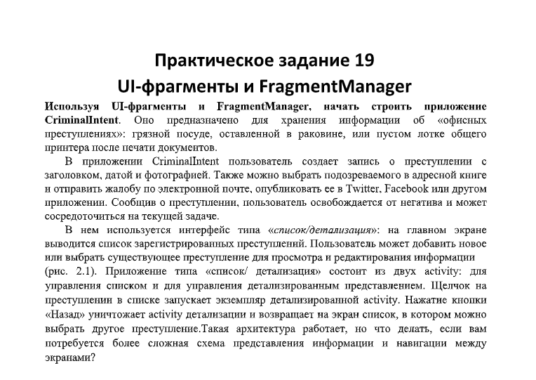

**Входные данные**

**Edit text – ввод офисных преступлений.**

**Выходные данные**

**Пока нет**

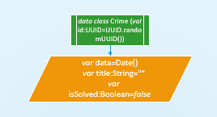**Блок схема**

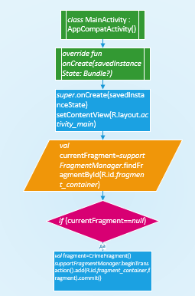

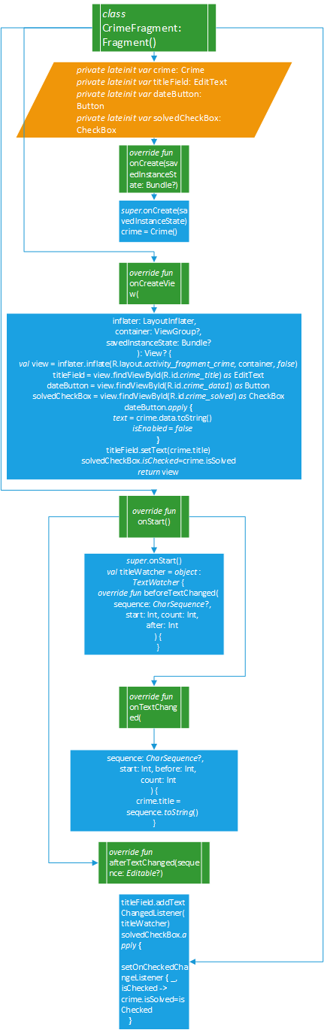

**Листинг программы**

**Activity_main**

<?xml version="1.0" encoding="utf-8"?>  
<LinearLayout xmlns:android="http://schemas.android.com/apk/res/android"  
 xmlns:app="http://schemas.android.com/apk/res-auto"  
 xmlns:tools="http://schemas.android.com/tools"  
 android:layout_width="match_parent"  
 android:layout_height="match_parent"  
 android:orientation="vertical"  
 android:layout_margin="16dp"  
 tools:context=".fragment_crime">  
  
 <TextView  
 android:layout_width="match_parent"  
 android:layout_height="wrap_content"  
 android:text="@string/crime_title_label"  
 android:textAllCaps="true"  
 android:textStyle="bold"  
 app:layout_constraintBottom_toBottomOf="parent"  
 app:layout_constraintEnd_toEndOf="parent"  
 app:layout_constraintStart_toStartOf="parent"  
 app:layout_constraintTop_toTopOf="parent" />  
 <EditText  
 android:id="@+id/crime_title"  
 android:layout_width="match_parent"  
 android:layout_height="wrap_content"  
 android:hint="@string/crime_title_hint"  
 >  
  
 </EditText>  
 <TextView  
 android:layout_width="match_parent"  
 android:layout_height="wrap_content"  
 android:textAllCaps="true"  
 android:textStyle="bold"  
 android:text="@string/crime_details_label"  
 >  
 </TextView>  
  
 <Button  
 android:id="@+id/crime_data1"  
 android:layout_width="match_parent"  
 android:layout_height="wrap_content"  
 android:text="Wed Nov 14 11:56 ETS 2018"  
 android:background="@color/purple_200"  
 >  
 </Button>  
 <CheckBox  
 android:id="@+id/crime_solved"  
 android:layout_width="match_parent"  
 android:layout_height="wrap_content"  
 android:text="@string/crime_solved_label"  
 >  
 </CheckBox>  
</LinearLayout>

**Crime**

package com.example.prakt19_1rmp  
  
import java.util.*  
  
data class Crime (val id:UUID=UUID.randomUUID())  
{  
 var data=Date()  
 var title:String=""  
 var isSolved:Boolean=false  
}

**Class_CrimeFragment**

class CrimeFragment: Fragment() {  
 private lateinit var crime: Crime  
 private lateinit var titleField: EditText  
 private lateinit var dateButton: Button  
 private lateinit var solvedCheckBox: CheckBox  
 override fun onCreate(savedInstanceState: Bundle?) {  
 super.onCreate(savedInstanceState)  
 crime = Crime()  
 }  
  
 @SuppressLint("MissingInflatedId")  
 override fun onCreateView(  
 inflater: LayoutInflater,  
 container: ViewGroup?,  
 savedInstanceState: Bundle?  
 ): View? {  
 val view = inflater.inflate(R.layout.*activity_fragment_crime*, container, false)  
 titleField = view.findViewById(R.id.*crime_title*) as EditText  
 dateButton = view.findViewById(R.id.*crime_data1*) as Button  
 solvedCheckBox = view.findViewById(R.id.*crime_solved*) as CheckBox  
 dateButton.*apply* **{** *text* = crime.data.toString()  
 *isEnabled* = false  
 **}** return view  
 }  
  
 override fun onStart() {  
 super.onStart()  
 val titleWatcher = object :  
 TextWatcher {  
 override fun beforeTextChanged(  
 sequence: CharSequence?,  
 start: Int, count: Int,  
 after: Int  
 ) {  
 }  
  
 override fun onTextChanged(  
 sequence: CharSequence?,  
 start: Int, before: Int,  
 count: Int  
 ) {  
 crime.title =  
 sequence.*toString*()  
 }  
  
 override fun afterTextChanged(sequence: Editable?) {  
  
 }  
 }  
 titleField.addTextChangedListener(titleWatcher)  
 solvedCheckBox.*apply* **{** setOnCheckedChangeListener **{** _, isChecked **->** crime.isSolved=isChecked  
 **}  
 }** }  
}

**fragment crime**

import android.support.v7.app.AppCompatActivity  
import android.os.Bundle  
  
class fragment_crime : AppCompatActivity() {  
 override fun onCreate(savedInstanceState: Bundle?) {  
 super.onCreate(savedInstanceState)  
 setContentView(R.layout.*activity_fragment_crime*)  
 }  
}

**Class main_activity**

class MainActivity : AppCompatActivity() {  
 override fun onCreate(savedInstanceState: Bundle?) {  
 super.onCreate(savedInstanceState)  
 setContentView(R.layout.*activity_main*)  
val currentFragment=*supportFragmentManager*.findFragmentById(R.id.*fragment_container*)  
 if (currentFragment==null)  
 {  
 val fragment=CrimeFragment()  
 *supportFragmentManager*.beginTransaction().add(R.id.*fragment_container*,fragment).commit()  
 }  
 }  
}

**Вывод**

